
Department of Business Economics, University of Delhi

Summer Internship
At
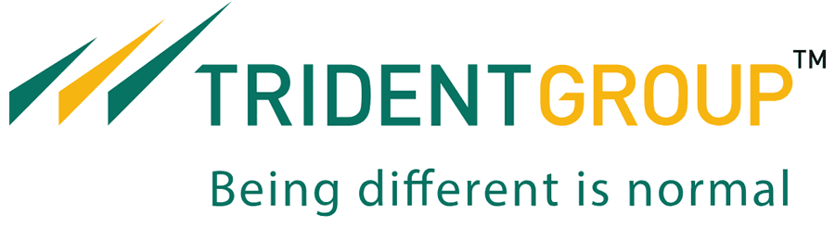

Project Report
On
1. Cost competitiveness of Trident VS other competitors
2. Selection of new vendor for Sulphur

Submitted To: Submitted by:
Mr. Gunjan Shroff - CFO Akanksha
Mr. Vivek Arora - DCFO, TPEC MBA BE
Batch: 2018-2020

ACKNOWLEDGEMENT

The presentation of the report in the way required has been made possible by the way of contribution of various people. It is my pleasure to be indebted to them who directly or indirectly contributed in the development of this work and who influenced my thinking, behavior, and acts during the course of study.
I express my sincere gratitude to Department of Business Economics, University of Delhi for providing me an opportunity to undergo summer training at Trident Group.
I extend my gratitude to Trident Group and Mr.Rajinder Gupta for giving me this opportunity.
I would like to express my deep and sincere gratitude to my mentors Mr.Gunjan Shroff and Mr.Vivek Arora for providing me invaluable guidance throughout this internship period. Their dynamism, vision, sincerity and motivation have deeply inspired me. It was a great privilege and honor to work and study with their guidance throughout the project.
I would also like to thank Mr.Gaurav Pahwa, Ms.Priya Khanna and Ms.Asmita Aneja who have helped me with their valuable suggestions and support.
Lastly, I would like to thank the almighty and my parents for their moral support and my friends who helped me during this internship period.

Date: August 02, 2019 Akanksha
MBA BE

Table of Contents
ACKNOWLEDGEMENT 2
Table of Contents 3
Project 1: Cost competitiveness of Trident VS other competitors 4
Comparison based on different parameters 4
Component wise cost comparison: 7
Ratio Analysis 8
EBITDA Margin trend 8
Trend Analysis 9
2. Paper 10
Comparison based on different parameters 10
Component wise cost comparison: 10
Ratio Analysis 11
EBITDA margin trend 11
3. Yarn 12
Component wise cost comparison 12
Ratio Analysis 13
EBITDA Margin trend 13
Trend Analysis 14
Conclusion 15
Textile 15
Paper 17
Yarn 17
References: 18
Project 2: Shortlisting of new vendor for Sulphur 19
Production of Sulphur in India 19
Sources of Sulfur in India 19
Production of Sulphur in World 21
Trade Policy 21
Country wise import of Sulphur 22
Country wise export of Sulphur 23
China sulphur price 23
Price as per invited quotations: 24
Comparison of Sulphur specification: 24
Savings due to new Sulphur 25
References: 26

Project 1: Cost competitiveness of Trident VS other competitors

1. Textile

Comparison based on different parameters

Parameters | Trident | Welspun | Indo Count | Himatsingka Seide
Vision | Vision by 2025  USD 3bn revenue | Vision by 2022  USD 2bn revenue  0 debt  50% innovative and branded product share  20% women employee  20% share of domestic revenue | To be one of the leading players in the global Home Textile industry on the strengths of technology, experience and innovation | To offer best-in-class textiles and made-ups for commercial and home applications, for every market segment and delivering to every geography.
Capacity per annum  - Bath Linen  - Bed Linen  - Rugs & carpet  - Drapery & upholstery | 90,000MT (largest)  43.2mn meters | 80,000MT  90mn meters  10Mn sq. meters | -  90mn meters | 25,000T (trial production)  61mn meters  -  2mn meters
Capacity utilization
   | FY19 | FY18
  Towel | 49% | 45%
  Bed Linen | 63% | 44%
   | FY19 | FY18
  Towel | 88% | 81%
  Bed Linen | 82% | 79%
  Rugs & Carpet | 70% | 63%
   | FY19 | FY18
  Bed Linen | 64% | 60%
Investment |  | Total 7.5bn in FY19  Expected in FY20- 6bn  Flooring- 5.6bn  Planned investment of 11bn for flooring solution and manufacturing in Telangana to serve domestic market better | Around Rs240cr in Maharashtra will be completed by FY20
Repayment of debt | Repayment of Long-Term Debt of INR 432crore in FY19, Net Debt reduced by INR 277crore  Debt equity ratio improved to 0.8 from 1 in FY18 | Debt equity ratio improved to 1.09 in FY19 from 1.27 in FY17 | Almost debt free | Increase .in debt-equity ratio from 1 in FY15 to 1.7 in FY19
Long term credit rating | AA- stable (by CARE)  A+ stable (by CRISIL) | Upgraded to AA from AA- (by CARE) | AA- (by CARE)  AA- (by ICRA) | A- (by CRISIL)
Revenue CAGR | 8.45% in towel since FY14 | 8.45% since FY14 | 5.36% since FY14 | 5.53% since FY14
Market share | US  12-13% in towel (grew at a CAGR of 12%) | US  19% in towel  10% in bed linen  Focus on growing market in India, Europe and Japan | Among top 3 bed sheets supplier to US
Market capitalization | 33,786mn | 59,948mn | 7,175.5mn | 3,441crores
Market Capitalization as on 1.07.2019 (in Rs) | 3156.94Cr | 5802.29Cr | 649.44Cr | 1581.71Cr
Contribution to total sales through e-commerce |  | 5%  Own e-commerce shopwelspun grew by 71%
Contribution of innovative products to sales |  | 38%
Contribution of branded products to sales |  | 17% |  | 75%
Revenue contribution | Export - 89%  - US 65-70%  - EU 15-20%  Domestic-11% | US 66-68%  EU 17-18%  India 6-7%  RoW 9-10% | Export -92%  US 65-70%  Export to 54 countries | North America 80%
Expenditure on R&D |  | 349million |  | 8.18crore
Share price trend (NSE) | 52week high- 75.70  52week low- 52.15 | 52week high- 78.25  52week low- 46.20 | 52week high- 89.60  52week low- 30.35 | 52week high- 321  52week low- 150.80
Towel Export | 1645Cr  19% of the total export from the country  Exports in Cr: -  ▪US- 43% less than WIL  ▪UK- 77% less than WIL  ▪Huge competition in UK due to WIL, SEL and Abhitex  ▪COSTCO has 433Cr business with Welspun and 75Cr with Kapoor industries but only 2Cr with Trident  ▪39,894MT opportunity without strong barrier to entry (24,456MT in US and 1049 MT in UK) | 2473Cr  29% of the total exports from the country  ▪Highest export (16,292MT) to Welspun/BBB and Kohls (8,475MT) in US  ▪Highest export (2303MT) to TESCO in UK
  Country | Trident | Welspun
  US | 1160 | 2034
  UK | 51 | 225
New products | Launched French brand Elle décor in India in 2016  Launched crafted range of Bed and Bath Linen collection in 2016 | 2-tier Christy Range developed:  Christy England and Christy Living  Lunched brand Tilt | In 2018 launched brand Heirlooms of India, Boutique Living Coastal and Atlas in US  Launched branch ‘Boutique living’ in India in 2016 | The studio develops over 1500 new product designs every year, of which about 1000 are launched.
Innovations | Nectarsoft – made up of supima cotton (American cotton) which has 35% longer staple length and 45%stronger than regular cotton gives silken feather effect  Organica- made from cotton bamboo, reduced carbon footprints renewable with an inherent anti-microbial property.  Use of air rich and twist management technology  Cuddlies towel for babies and hooded bath apron | One new innovation every six months  Hygrocotton – contributes $180Mn of sales  Wel-trak fiber – contributes 3% of total revenue  Charcoal- Sports towels and bed sheets that are not washed often. It gives natural odor control benefits.  Interactive textile Tilt: integration of smart technology with home textiles. It is an interactive and innovative bed set and rug for kids. | key innovations under “sleep sensation”:  1. Infinity: National Sleep Foundation recognized line of high thread-count, super-breathable Infinity sheets will redefine comfort  2. Signature: created revolutionary sheet which is new to the market by the name of HD Sateen sheet under signature sheet umbrella | PimaCott (developed by Himatsingka America) is the only pima cotton that can be forensically tracked and traced back to source.
Patent | Patented Air Rich Yarn and Fabric and its method of manufacturing by US Patent & Trademark Office. | Patented traceability solution wel-trak  Augmented reality system | True grip fit technology- gives perfect fit on mattresses  Infinity cotton- exceptionally soft and long-lasting luster | DNA tagging technology- the ability to attach DNA markers to every fiber and facilitating to track product through every phase of value chain
Certifications | Certified with OEKO-TEX Made in Green label. The Made in Green label is traceable allowing consumers to easily trace the manufacturing supply chain, bringing in more transparency to shoppers  Bed Linen, terry towel and yarn certified with Prestigious ‘Egyptian Gold Seal’ | Asthma and allergy free certification  OEKO-TEX standard 100  ISO 140001 EMS  ISO 9001 QMS  ISO17025 LMS | Egyptian cotton gold seal  OEKO-TEX confidence in textile  Supima world’s finest cotton  Supplier ethical data exchange (sedex) | OEKO-TEX Standard 100  Supima License  Egyptian Cotton License
Customer satisfaction |  | 80% revenue from replenishment
Associations |  | Wimbledon, Rugby world cup, IPL official partner for Kings XI Punjab
Acquisition |  | In 2006, Welspun acquired Christy’s of UK which has privilege to cater to British royal family. Christy brand is also being introduced globally including the US, China and the Middle East. | In 2008, Acquired Pranavaditya Spinning Mills Limited | In 2007, Acquired Bellora of Italy, Divatex Home Fashions, the  Acquisition of DWI Holdings a leading branded Home Textile player in the North American market and a licensee of the Calvin Klein Home and Barbara Barry brands.
Opportunities | ▪Leverage existing customer relationship to further expand Bed Linen business  ▪Optimize capacity utilization levels and continue to improve operational efficiencies  ▪Expand business through organic growth and strategic inorganic opportunities  ▪Improve brand presence through multi brand outlets (MBOs) and e-commerce platforms  ▪Expanding towel business with Ross Procurement, Macy’s merchandising group and Kmart because they have huge demands fulfilled by companies other than Trident and WIL  ▪18,561MT,4246MT and 902MT towel market in US, Europe and UK respectively having supply from India but from companies other than Trident and WIL can be tapped | ▪US hospitality market for towel and sheets is $1.5bn. Welspun has only 3%.  Global wellness economy $3.7 trillion  ▪partnered with StayWell (infuses wellness into hotel rooms with features and programs to maximize guest experience) to top global wellness potential  ▪Tie up with leading hotel chains and wellness centers  ▪Increased focus on B2B business and tapping domestic market potential. It has designed the brand strategy of the domestic market brand ‘spaces’ | ▪Progressive investments in state-of-the-art technology  ▪Strengthening design department to promote and service fashion bedding requirements  ▪Tap newer geographies  Initiatives in branding, distribution and e-commerce  ▪Prudent capital allocation for growth | ▪Potential to increase non-US revenues to over 40% in the next 2-3 years  ▪Will be focused on European region through FY21  ▪Increasing pricing power through enhancing brand portfolio

Component wise cost comparison:

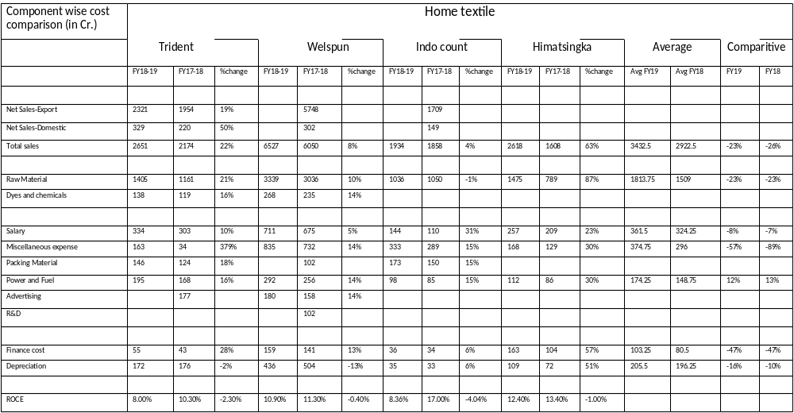

Ratio Analysis
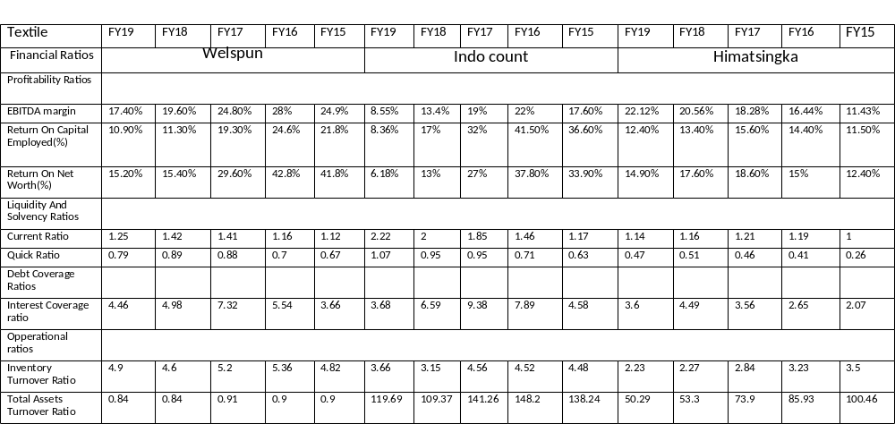

EBITDA Margin trend
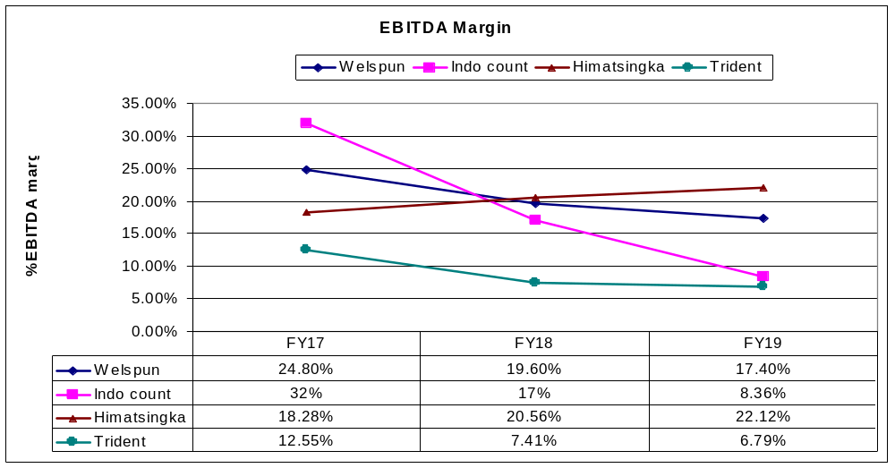

Trend Analysis

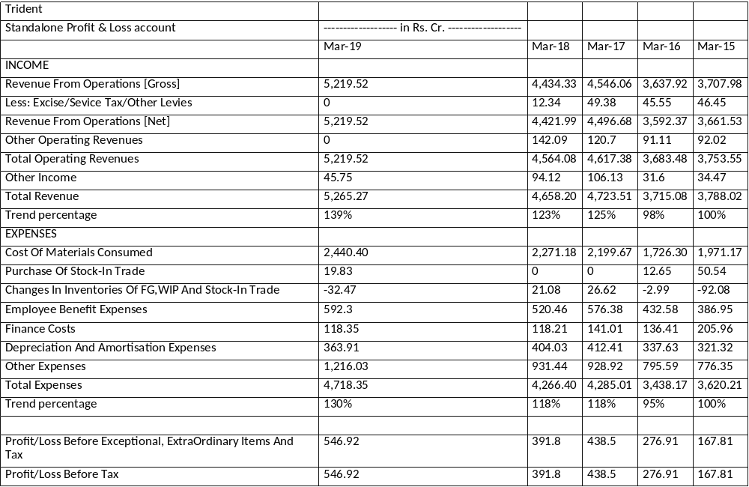

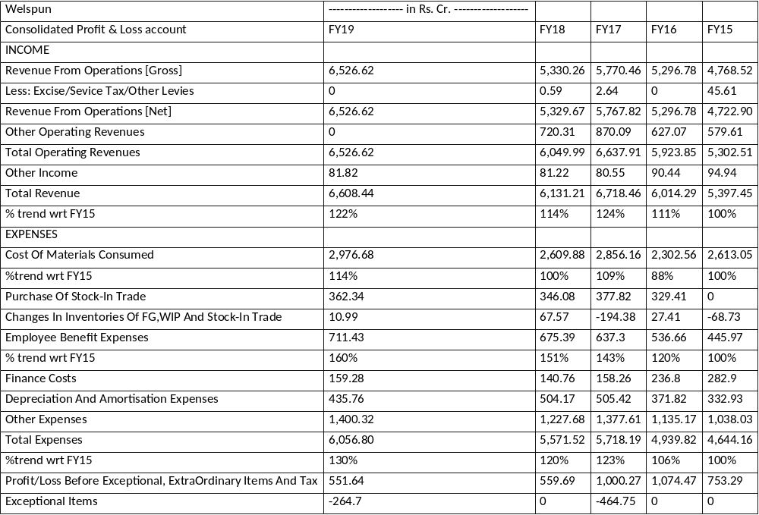

2. Paper

Comparison based on different parameters

Parameters | Trident | JK paper | Kuantum
Raw material | Wheat straw based | Wood based | Wild agro vegetation and agro-residues
Capacity | 1,75,000TPA | 5,93,000TPA (after acquiring Sirpur paper mills) | 1,27,750TPA
Capacity utilization | 89% | 104% (before acquisition)
Market capitalization as on 1.07.2019 (in Rs) | 3156.94Cr | 2,253Cr  60% increase over FY17 | 349.05Cr
Geographic presence | Domestic 88%  Exports 12% | As per FY18 sales by volume  Domestic 90%  Export 10%
Product mix market share | Branded copier paper 10% | Copier paper 23%
Revenue from product mix | Branded copier paper 48%
Repayment of debt | Repayment of Long-Term Debt of INR 432crore in FY19, Net Debt reduced by INR 277crore  Debt equity ratio improved to 0.8 from 1 in FY18 | Repaid high-cost debt of 460crore in FY18  Debt-equity ratio improved to 0.64 from 1.68 in FY16
Long term credit rating | AA- stable (by CARE)  A+ stable (by CRISIL) | upgraded to A+ from BBB+ in FY16 | Upgraded to A- stable from BBB+
Share price trend (NSE) | 52 week high- 75.70  52 week low- 52.15 | 52 week high- 194.20  52 week low-97.30 | 52 week high- 821.90  52 week low-376.65
Acquisition |  | Acquired The Sirpur Paper Mills having capacity of 1,38,000TPA through insolvency and bankruptcy code(IBC) process
New product |  | -In FY18 launched A5 range of paper  -First in India to produce and market ColorLok copier paper

Component wise cost comparison:
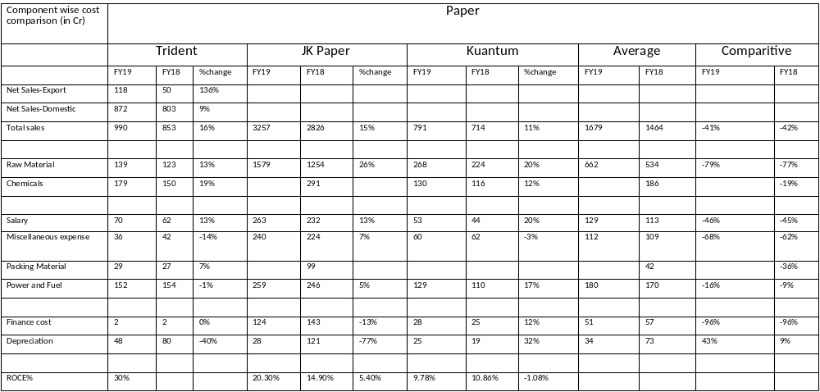

Ratio Analysis

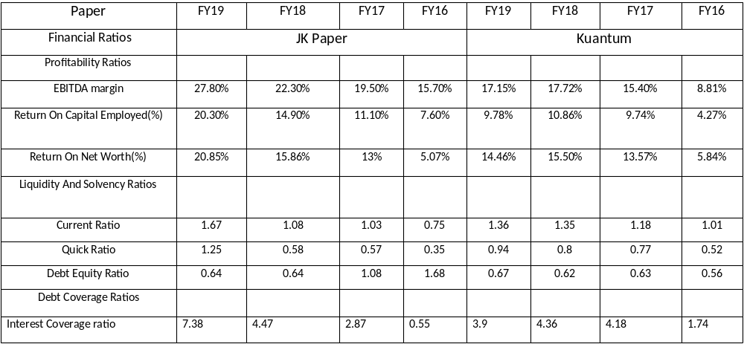

EBITDA margin trend

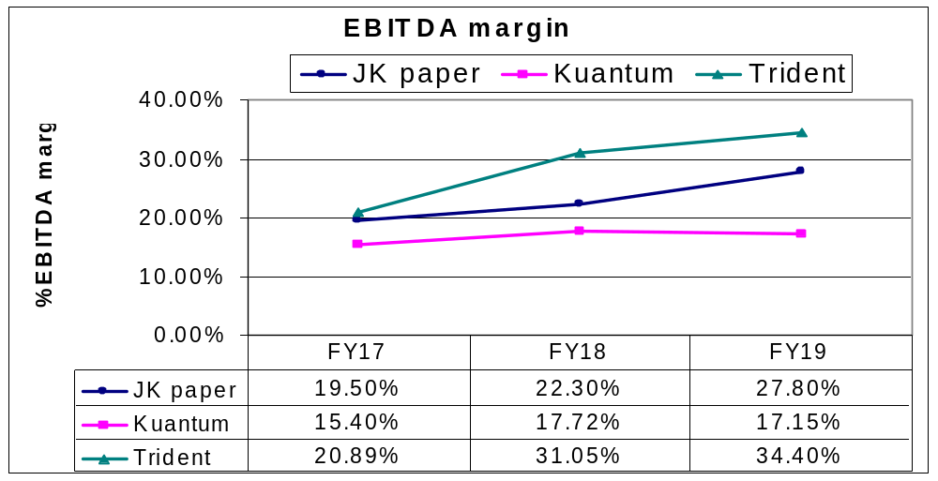

3. Yarn

Parameters | Trident | Vardhman | Nahar
Capacity | 5.83lakhs spindles | 11.02lakhs spindles  (Largest in the country)  580MT/day | 5.34lakhs spindles
Capacity utilization | 98% | 96%
Capex |  | 105Cr in FY18  Planning to add 1,00,000 spindles by FY20 | 150Cr inFY18 to add 36480 spindles
Market Capitalization as on 1.07.2019 (in Rs) | 3156.94Cr | 6,036.72Cr | 255.88Cr
Share price trend (NSE) | 52 week high- 75.70  52 week low- 52.15 | 52 week high- 1241.05  52 week low- 920 | 52 week high-109.80  52 week low- 67.45
New market added |  | Fiji and Costa Rica
No. of countries yarn is exported to | 37 | 65
Long term credit rating | AA- stable (by CARE)  A+ stable (by CRISIL) | AA+ (by CRISIL) | A stable
Revenue CAGR | 6.5% since FY14 | 5.2% in FY14-18 | 1.77% since FY14
Debt equity ratio | 0.8 | 0.43 | 0.22

Component wise cost comparison:

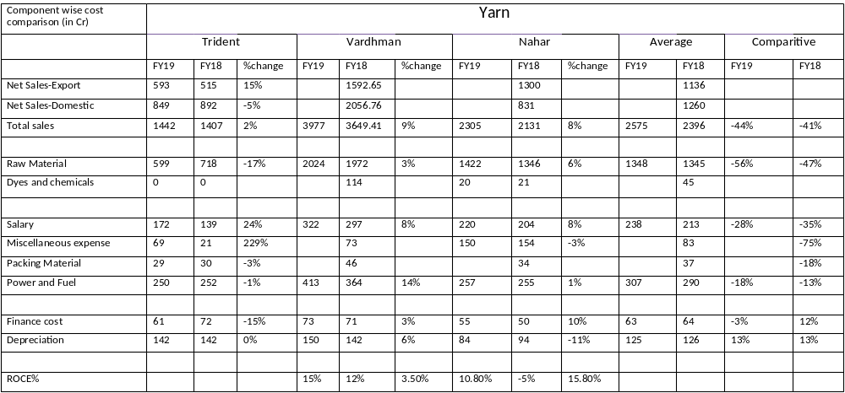

Ratio Analysis

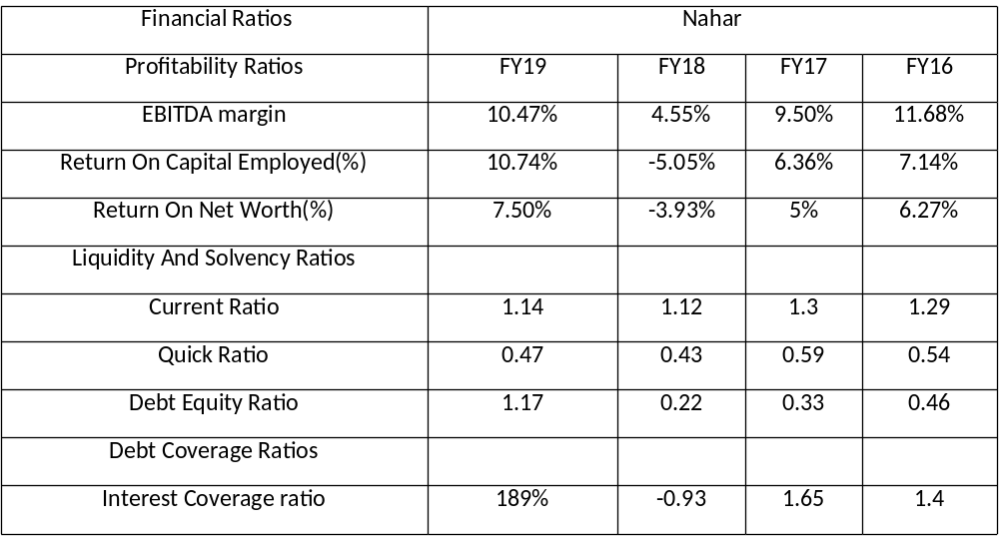

EBITDA Margin trend
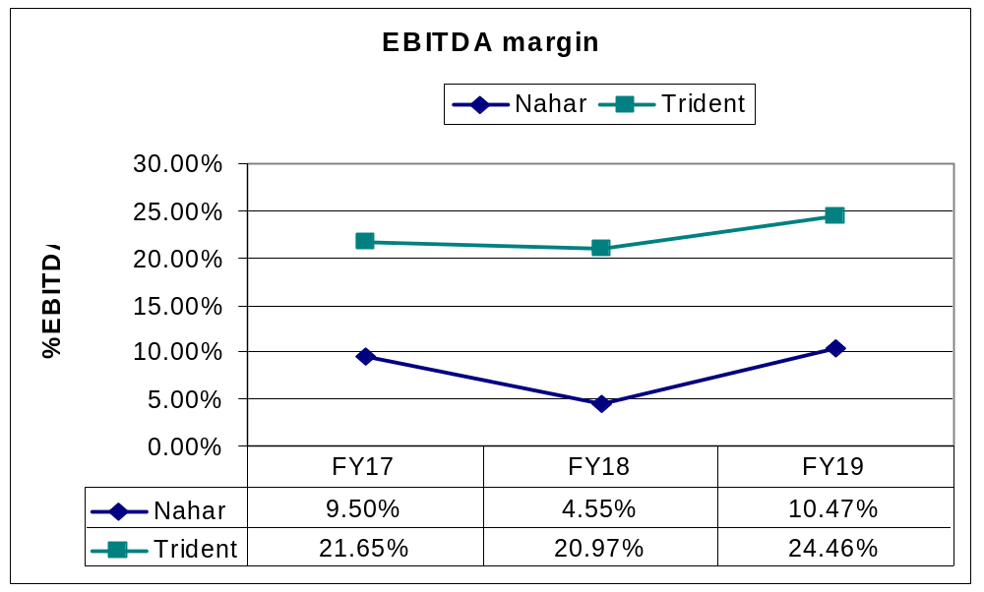

Trend Analysis

Nahar Spinning Mills | ------------------- in Rs. Cr. -------------------
Standalone Profit & Loss account | FY19 | FY18 | FY17 | FY16 | FY15
INCOME
Revenue From Operations [Gross] | 2,305.20 | 2,130.66 | 2,129.27 | 2,025.10 | 2,145.09
Less: Excise/Sevice Tax/Other Levies | 0 | 0 | 0.04 | 0.1 | 0.01
Revenue From Operations [Net] | 2,305.20 | 2,130.66 | 2,129.23 | 2,025.00 | 2,145.07
Other Operating Revenues | 0 | 2.53 | 2.89 | 4.08 | 4.54
Total Operating Revenues | 2,305.20 | 2,133.19 | 2,132.12 | 2,029.08 | 2,149.61
Other Income | 12.65 | 9 | 22 | 18.03 | 11.3
Total Revenue | 2,317.85 | 2,142.19 | 2,154.11 | 2,047.12 | 2,160.91
% trend wrt FY15 | 107% | 99% | 100% | 95% | 100%
EXPENSES
Cost Of Materials Consumed | 1,422.03 | 1,346.28 | 1,287.68 | 1,124.00 | 1,274.49
Purchase Of Stock-In Trade | 3.98 | 4 | 4.32 | 5.6 | 4.67
Changes In Inventories Of FG,WIP And Stock-In Trade | -32.33 | 26.11 | -14.82 | 4.29 | -2.8
Employee Benefit Expenses | 220.19 | 204.48 | 196.85 | 196.74 | 176.18
Finance Costs | 55.05 | 49.75 | 41.03 | 57.67 | 79.48
Depreciation And Amortisation Expenses | 83.61 | 94.07 | 95.83 | 101.07 | 130.56
% trend wrt FY15 | 64% | 72% | 73% | 77% | 100%
Other Expenses | 461.21 | 463.81 | 475.53 | 477.42 | 483.82
Total Expenses | 2,213.75 | 2,188.49 | 2,086.41 | 1,966.79 | 2,146.40
% trend wrt FY15 | 103% | 102% | 97% | 92% | 100%
Profit/Loss Before Exceptional, ExtraOrdinary Items And Tax | 104.1 | -46.31 | 67.7 | 80.33 | 14.51
Exceptional Items | 0 | 0 | 0 | -1.2 | 0.33
Profit/Loss Before Tax | 104.1 | -46.31 | 67.7 | 79.13 | 14.84
% trend wrt FY15 | 701% | -312% | 456% | 533% | 100%
Tax Expenses-Continued Operations
Current Tax | 38.38 | 0 | 25.1 | 29.75 | 9.5
Deferred Tax | 0 | -14.12 | -3.37 | -1.49 | -8.88
Total Tax Expenses | 38.38 | -14.12 | 21.73 | 28.26 | -5.53
Profit/Loss After Tax And Before ExtraOrdinary Items | 65.72 | -32.18 | 45.97 | 50.87 | 20.37
Profit/Loss From Continuing Operations | 65.72 | -32.18 | 45.97 | 50.87 | 20.37
Profit/Loss For The Period | 65.72 | -32.18 | 45.97 | 50.87 | 20.37
% trend wrt FY15 | 323% | -158% | 226% | 250% | 100%

Conclusion

Textile
▪Strengths
- World's largest terry towel manufacturers
- Achieved 50% increase in domestic sales from 220Cr in FY18 to 329Cr in FY19
- Trident Home Textiles secured 1st Rank globally by Walmart Sustainability survey 2018-19
- Wide range of product portfolio
- 2nd largest exporter of towel from India
- Low debt-equity ratio (0.8) means that the company has stronger equity position
- Low finance cost (47% less than average of competitor’s finance cost)

▪Weaknesses
- Lowest capacity utilization and slow growth rate among competitors
- High dependency on government export incentives
- Lack in R&D and innovations as compared to Welspun which launches one innovative product every 6 months and draws 38% of its revenue from innovative products
- Sales of sheets in FY19 is 590Cr which is 69% less than sales by Indo count
- Lack in branding through association with coveted tournaments like Welspun has association with Wimbledon, Rugby world cup, IPL, Disney and Minions
- No photo shoot of new launched designs only 3D pictures are published in product catalogue
- No own e-commerce website
- No Trident product is listed when searched ’buy bed sheet/ towel online’
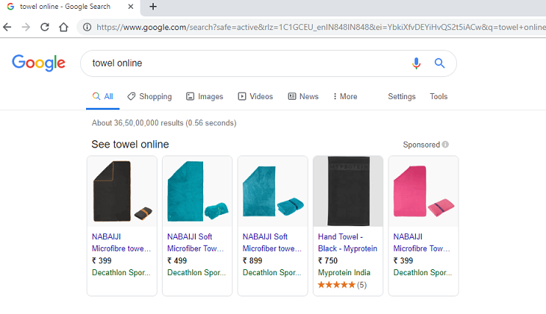
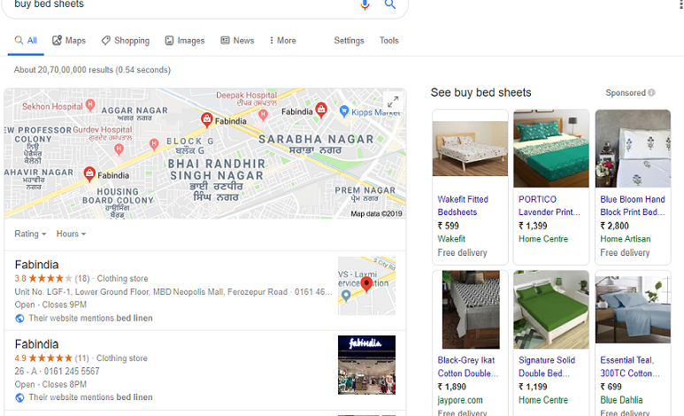

- Himatsingka is also ahead in terms of branding by acquiring luxury brands such as Bellora of Italy, Divatex home fashion and DWI holdings which has exclusive license for sourcing, marketing and distribution of luxury home textile brands- Barbara Barry, Bellora Hospitality, Calvin Klein Home
- Exports in Cr: -
Country | Trident | Welspun
US | 1160 | 2034
UK | 51 | 225
▪US- 43% less than WIL
▪UK- 77% less than WIL

▪Opportunities
- Optimize capacity utilization levels of both towel and sheets
- Adding domestic store locator on website to provide convenience in finding stores to customers
- Using Search Engine Optimization (SEO) to show Trident’s products as top result for searches made online
- Using augmented reality to see which sheet looks good on the bed
- Innovating technical textile (fire retardants, anti-bacterial, soil and stain resistant )
-fastest growing textile segment at the global level and expected to expand at a CAGR of 13.11% during FY18–23 to US$ 32 billion in FY23
-The government has supported the technical textile industry with an allotment of US$ 1 billion for SMEs and an exemption in custom duty for raw materials used by the sector.
- Strengthening brand portfolio, e-commerce and multi branded outlets presence
- Using branding campaign with tag line as part of promotion
- Tapping US hospitality market of towel and sheets which is $1.5bn and Welspun has only 3% of it.
- 18,561MT,4246MT and 902MT towel market in US, Europe and UK respectively have supply from India but from companies other than Trident and WIL can be tapped
- Tapping 39,894MT opportunity in towel market without strong barrier to entry (24,456MT in US and 1049 MT in UK)
- Expanding towel business with Ross Procurement, Macy’s merchandising group and Kmart because they have huge demands fulfilled by companies other than Trident and WIL

Paper
▪ Strengths
- Environment friendly, saves 5,000 trees a day
- 89% capacity utilization
- In 2017, launched a mobile app for the customer engagement program ‘Together Stronger’ to engage with customers and reach out to end consumers. It helped in maintaining the entire data of dealer, retailer and the amount of paper they are selling to the customers. It also helped in attracting dealers and retailers by giving them points on scanning each rim of paper which they can redeem for gifts.
- Very low finance cost as compared to competitors

▪ Weaknesses
- No major capital expenditure in last 12 years for capacity enhancement
▪ Opportunities
- Enhancing capacity and utilization level
- Increasing export sales volumes
- Procuring and recycling wasted paper
- Innovating organic disposable tableware(glass, cups etc)/ supply raw materials
- global paper cups and paper plates market reached a value of nearly US$ 106 Billion in 2018 and is expected to grow at a projected CAGR of 2%
Source: www.researchandmarkets.com
- Innovating value added paperboards
- it is projected to grow at a rate of around 10.5% CAGR in India driven by growth in demand from the FMCG, Pharma, Publishing, and Food & Beverage industries
Source: ITC annual report 2019
- Innovating green packaging
- It is expected to reach a value of US$ 238.6 Billion by 2024, at a projected CAGR of around 6% during 2019-2024
Source:www.imcargroup.com

Yarn
▪ Strengths
- Full capacity utilization
- Cotton availability in abundance

▪ Weaknesses
- Sales increased only 2% from 1407Cr in FY18 to 1442Cr FY19
- Export to only 37 countries whereas Vardhman exports to 65 countries

▪ Opportunities
- Diversifying product portfolio
- Adding capacity level
- Value added product manufacturing
- Increasing domestic and export volumes and tapping new geographies

References:
- https://www.tridentindia.com/webroot/reports/5c9462f40553b_1553228532_PPT.pdf
- https://www.tridentindia.com/webroot/reports/5cd95f776e5b4_1557749623_TridentEarningsPresentationQ4FY19.pdf
- https://www.tridentindia.com/webroot/reports/Bed_Catalogue_2018.pdf
- https://www.tridentindia.com/webroot/reports/Bath_Catalogue_2018.pdf
- https://www.tridentindia.com/webroot/reports/59aedcf1803f1_1504632049_CRISIL.pdf
- https://www.tridentindia.com/webroot/reports/5b7e54176cdbe_1535005719_Annual_Report_FY_2017-18.pdf
- https://www.tridentindia.com/webroot/reports/5c64124c211ff_1550062156_Press%20Release_Air%20Rich.pdf
- https://www.tridentindia.com/webroot/reports/5aa3d899511ba_1520687257_Trident%20Vision%202025%20Targeting%20USD%203%20Billion%20Revenue.pdf
- https://www.tridentindia.com/webroot/reports/5aab6f9d14a12_1521184669_OEKO%20TX%20Label%20PressRelease.pdf
- https://www.tridentindia.com/webroot/reports/58eb3a4276bbd_1491810882_Trident%20Bed%20Linen%20-%20Egyptian%20Cotton%20Gold%20Seal%20Press%20Release.pdf
- https://www.tridentindia.com/webroot/reports/Press%20Release%20-%20TRIDENT%20launches%20Bed%20and%20Bath%20Linen%20collection.pdf
- https://www.tridentindia.com/webroot/reports/Press%20Release%20-%20Trident%20launches%20French%20Brand%20ELLE%20DECOR%20in%20India.pdf
- http://www.welspunindia.com/investors_uploads/WIL%20AR%20%20low.pdf
- http://www.welspunindia.com/investors_uploads/Q4FY19_Welspun%20India_Investor%20Presentation_2.pdf
- http://www.welspunindia.com/investors_uploads/Q3FY19_Welspun%20India_Investor%20Presentation.pdf
- http://www.welspunindia.com/investors_uploads/Q2FY19_Welspun%20India_Investor%20Presentation.pdf
- http://www.welspunindia.com/investors_uploads/Q1FY19_Welspun%20India_Investor%20Presentation.pdf
- https://www.bseindia.com/
- https://www.indocount.com/images/investor/Credit-Rating_190221_053044.pdf
- https://www.indocount.com/images/investor/Investor-Presentation-FY2018-19-Results.pdf
- https://www.indocount.com/images/investor/Investor-Presentation-FY2018-19-Results.pdf
- https://www.indocount.com/images/investor/Annual-Report-for-2017-18.pdf
- https://www.jkpaper.com/
- https://www.kuantumpapers.com/
- https://www.vardhman.com/

Project 2: Selection of new vendor for Sulphur

Production of Sulphur in India

Production of by product Sulphur (by State) in tonnes
State | 2015-16 | 2016-17 | Rank
Assam | 4312 | 6559 | 9
Bihar | 5561 | 8159 | 8
Gujarat | 101743 | 100952 | 2
Haryana | 178688 | 190946 | 1
Kerala | 32169 | 33288 | 7
Maharashtra | 56670 | 48991 | 4
Odisha | 0 | 86734 | 3
UP | 47836 | 46618 | 5
West Bengal | 46343 | 38580 | 6
Total | 473322 | 560827

Sources of Sulfur in India:

- IOCL
During the year 2016-17, IOCL contributed about 84.60% of the total production during the year.

Refinery-wise Sulphur production for Indian Oil Corporation Ltd
Purity (99.9%)

Refinery | Production capacity (‘000MTPA)
Panipat | 144
Mathura | 48
Haldia | 24
Koyali | 18
Barauni | 12
Guwahati | 0.6

- HPCL
- Guru Gobind Singh refinery- HMEL (joint venture between HPCL and Miital energy investment )
- Shell
- BPCL
Mumbai and Kochi refineries
- RIL Jamnagar refinery
- Chennai Petroleum Corporation limited
Purity 99.96%
- ONGC Mangalore refinery and petrochemical limited
- Numaligarh refinery limited
Production in 2018 – 5,000 MT
- Mahaveer surfactants pvt ltd Chennai
(Production capacity- 36,000 MTPA)
- Nayara Energy, Vadinar oil terminal limited Gujarat
- Jaishil Sulphur and chemical industries Mumbai
- M.K chemical industries Delhi

Production of Sulphur in World

World production of Sulphur (by country) in '000 tonnes
Country | 2015 | 2016 | as % of total production in 2016 | Rank | Exchange rate
Brazil | 530 | 531 | 0.7% | 21 | 18.4
Canada | 5745 | 5317 | 7.1% | 5 | 52.85
China | 12500 | 12500 | 16.6% | 1 | 10.03
Chile | 1488 | 1596 | 2.1% | 14 | 0.1
Finland | 479 | 480 | 0.6% | 24 | 77.36
Germany | 1012 | 930 | 1.2% | 17 | 77.36
India | 2700 | 2700 | 3.6% | 10 | 1
Iran | 2200 | 2200 | 2.9% | 12 | 0.0021
Italy | 740 | 740 | 1.0% | 19 | 77.36
Japan | 3363 | 3518 | 4.7% | 7 | 0.64
Jordan | 490 | 490 | 0.7% | 23 | 97.27
Kazakhstan | 3119 | 3140 | 4.2% | 8 | 0.18
Netherlands | 507 | 512 | 0.7% | 22 | 38.6
Peru | 556 | 556 | 0.7% | 20 | 20.96
Turkmenistan | 410 | 410 | 0.5% | 26 | 19.67
Korea | 2528 | 3078 | 4.1% | 9 | 0.059
Mexico | 1414 | 1229 | 1.6% | 15 | 3.63
Poland | 931 | 925 | 1.2% | 18 | 18.22
Russia | 7156 | 7140 | 9.5% | 4 | 1.1
Saudia Arabia | 4400 | 4400 | 5.8% | 6 | 18.39
South Africa | 277 | 281 | 0.4% | 27 | 4.96
USA | 9536 | 9780 | 13.0% | 2 | 68.98
UAE | 2530 | 2530 | 3.4% | 11 | 18.78
Venezuela | 420 | 420 | 0.6% | 25 | 6.9
Spain | 1054 | 1054 | 1.4% | 16 | 77.36
Qatar | 1665 | 1667 | 2.2% | 13 | 18.94
Other Countries | 7350 | 7176 | 9.5% | 3
Total | 75100 | 75300 | 100.0%

Trade Policy
Imports of sulphur of all kinds other than colloidal sulphur, precipitated sulphur and sublimed (flowers) sulphur are allowed freely under the Foreign Trade Policy (FTP), 2015-20

Country wise import of Sulphur
Imports are mainly from Saudi Arabia (41%), Qatar (23%), UAE (18%), Japan (5%) and Bahrain (4%).

Import of Sulphur (excluding sublimed, precipitated and colloidal ) by countries
 | 2015-16 |  | 2016-17 |  | Average Price per MT | Average Price per MT
Country | Quantity (tonnes) | Value ('000 Rs) | Quantity (tonnes) | Value('000 Rs) | 2015-16 | 2016-17
Saudi Arabia | 415748 | 4194548 | 548366 | 3597521 | 10089 | 6560
Qatar | 495750 | 4870906 | 312818 | 1974246 | 9825 | 6311
UAE | 213666 | 2008392 | 244557 | 1535046 | 9400 | 6277
Japan | 64214 | 655506 | 70190 | 483295 | 10208 | 6886
Bahrain | 103358 | 993178 | 56909 | 365002 | 9609 | 6414
Kuwait | 87484 | 889808 | 52503 | 351483 | 10171 | 6695
Iran | 517 | 3507 | 39296 | 248471 | 6783 | 6323
Oman | 7475 | 106653 | 9575 | 100678 | 14268 | 10515
Singapore | 7010 | 65519 | 4734 | 35525 | 9347 | 7504
Turkmenistan | 15980 | 140589 | 4871 | 29642 | 8798 | 6085
Other Countries | 21430 | 244004 | 1701 | 30519 | 11386 | 17942

Country wise export of Sulphur

Export of Sulphur (excluding sublimed, precipitated and colloidal ) by countries
 | 2015-16 |  | 2016-17 |  | Average Price per MT | Average Price per MT
Country | Quantity  ( tonnes) | Value  ('000 Rs) | Quantity (tonnes) | Value  ('000 Rs) | 2015-16 | 2016-17
China | 503308 | 4034135 | 521873 | 2885689 | 8015 | 5529
Indonesia | 29700 | 181698 | 60500 | 340083 | 6118 | 5621
South Africa | 57 | 921 | 27039 | 140305 | 16158 | 5189
Brazil |  |  | 2019 | 22386 |  | 11088
Oman | 19 | 943 | 2105 | 21304 | 49632 | 10121
Sri Lanka | 788 | 15053 | 825 | 13949 | 19103 | 16908
Yemen Republic | 660 | 12699 | 400 | 7478 | 19241 | 18695
Turkey |  |  | 99 | 7411 |  | 74859
Nepal | 1469 | 23611 | 455 | 5816 | 16073 | 12782
Mayanmar |  |  | 425 | 5669 |  | 13339
Other Countries | 92163 | 888018 | 732 | 19260 | 9635 | 26311
Total | 628164 | 5157078 | 616472 | 3469350 | 8210 | 5628

China sulphur price
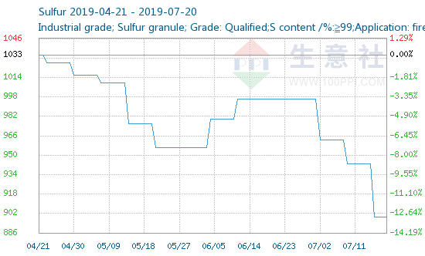
Date | Price (in Yuan) | Price (in Rs)
2019-07-19 | 900.00 | 9009.01
2019-07-18 | 900.00 | 9009.01
2019-07-17 | 900.00 | 9009.01
2019-07-16 | 900.00 | 9009.01
2019-07-15 | 943.33 | 9442.74
2019-07-14 | 943.33 | 9442.74

Price as per invited quotations:

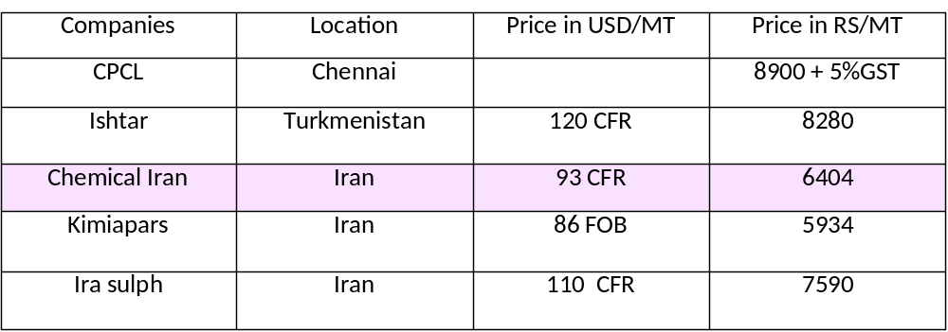

Comparison of Sulphur specification:

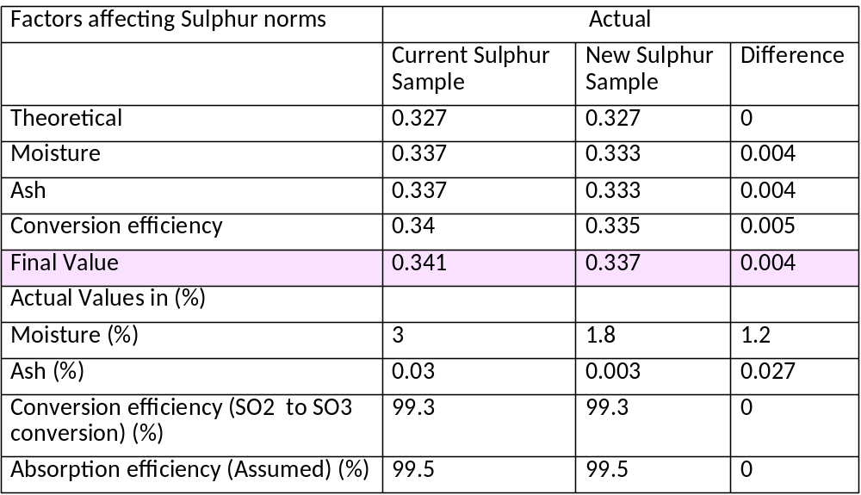

Savings due to new Sulphur

Savings due to new Sulphur quality
Acid production (TPD) | 260
Gain due to new Sulphur (Final value) | 0.004
Gain per day (TPD) | 1.04
Gain per month (MT) | 31.2
Current Sulphur price (Rs/MT) | 8146
Savings per month (Rs) | 254155.2
Overall Savings
New Sulphur price (Rs) | 6404.12
Savings (Rs/MT) | 1741.88
Savings for 3000 MT | 5225640
Total savings per month (Rs) | 5479795.2

Calculation of freight
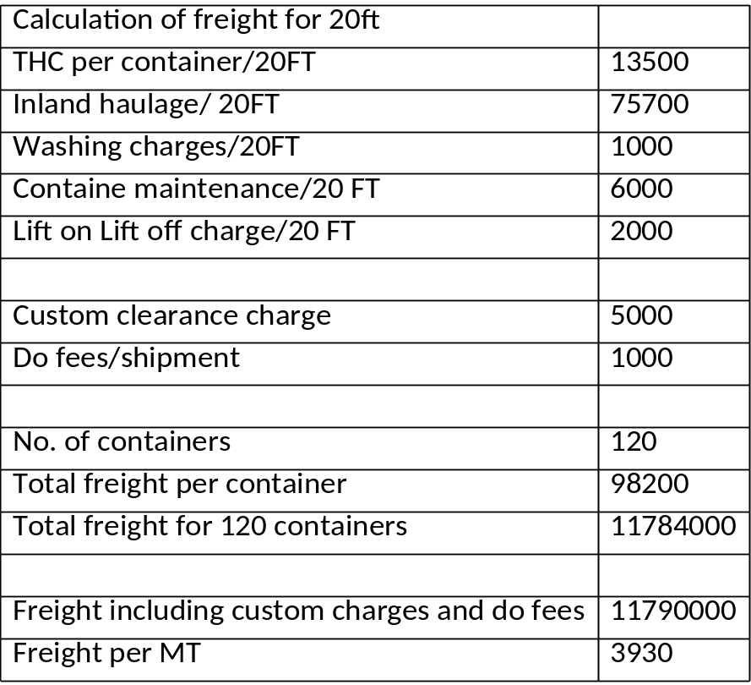
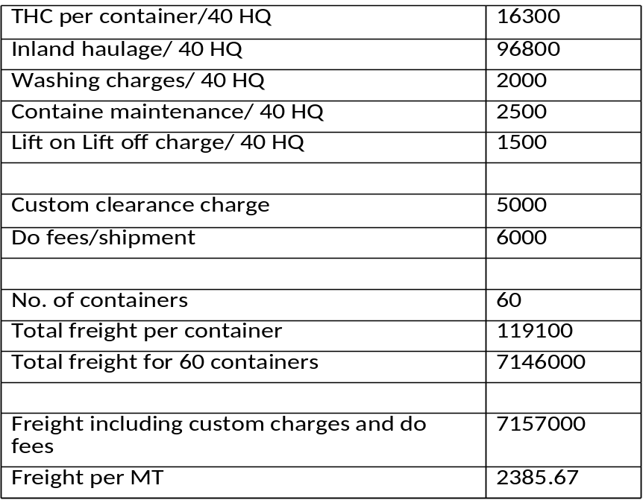

Calculation of break even

Let x be the current Sulphur price.

31.2x + 3000(x-6404) = 7146000

x= 8695.56

So the alternative of importing Sulphur from Iran is only feasible if current price of Sulphur from HMEL exceeds INR 8,695.

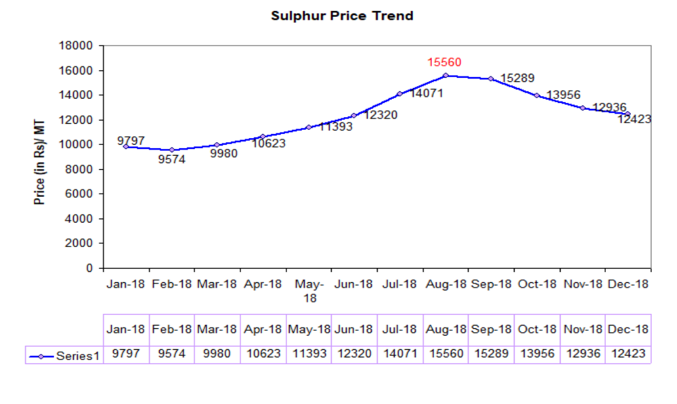

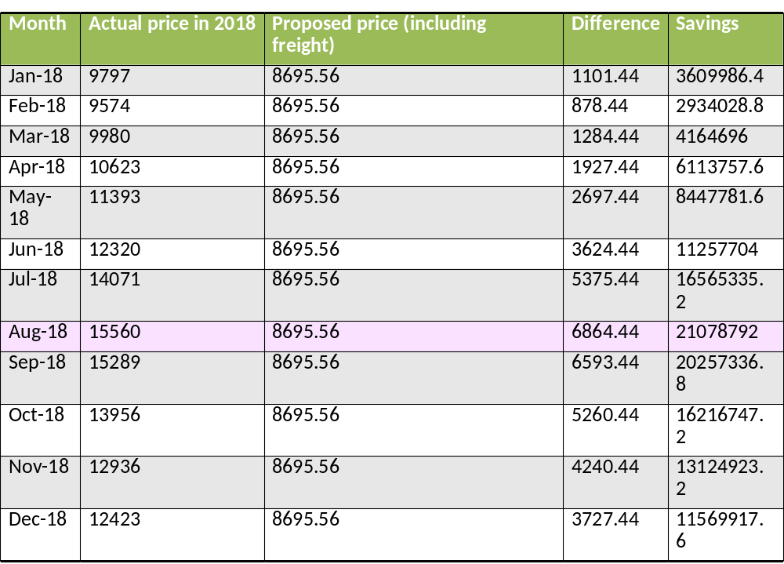

Savings is calculated as 31.2x + 3000(x-6404) = 7146000 where x is price of actual price of sulphur in 2018

CONCLUSION

The price of Sulphur is very volatile and the current vendor doesn't have the required capacity for storage purpose.

Hence it is proposed to buy from the prospective vendor to store (in order to use it when the price goes high) as this is the next best option.

References:

1. http://www.sunsirs.com/uk/prodetail-427.html
2. file:///C:/Users/internldh/Downloads/argus-north-american-sulphur-and-sulphuric-acid%20(1).pdf
3.http://ibm.nic.in/writereaddata/files/01092018173342Sulphur%20and%20Pyrites%202016%20(Advance% 20Release).pdf
4. http://ibm.nic.in/writereaddata/files/12102018174559Sulphur_and_pyrite2017.pdf
http://www.firt.org/sites/default/files/3PeterHarrison.pdf

